1. Write a Java program to count the number of characters in the last word of a given string **s**.

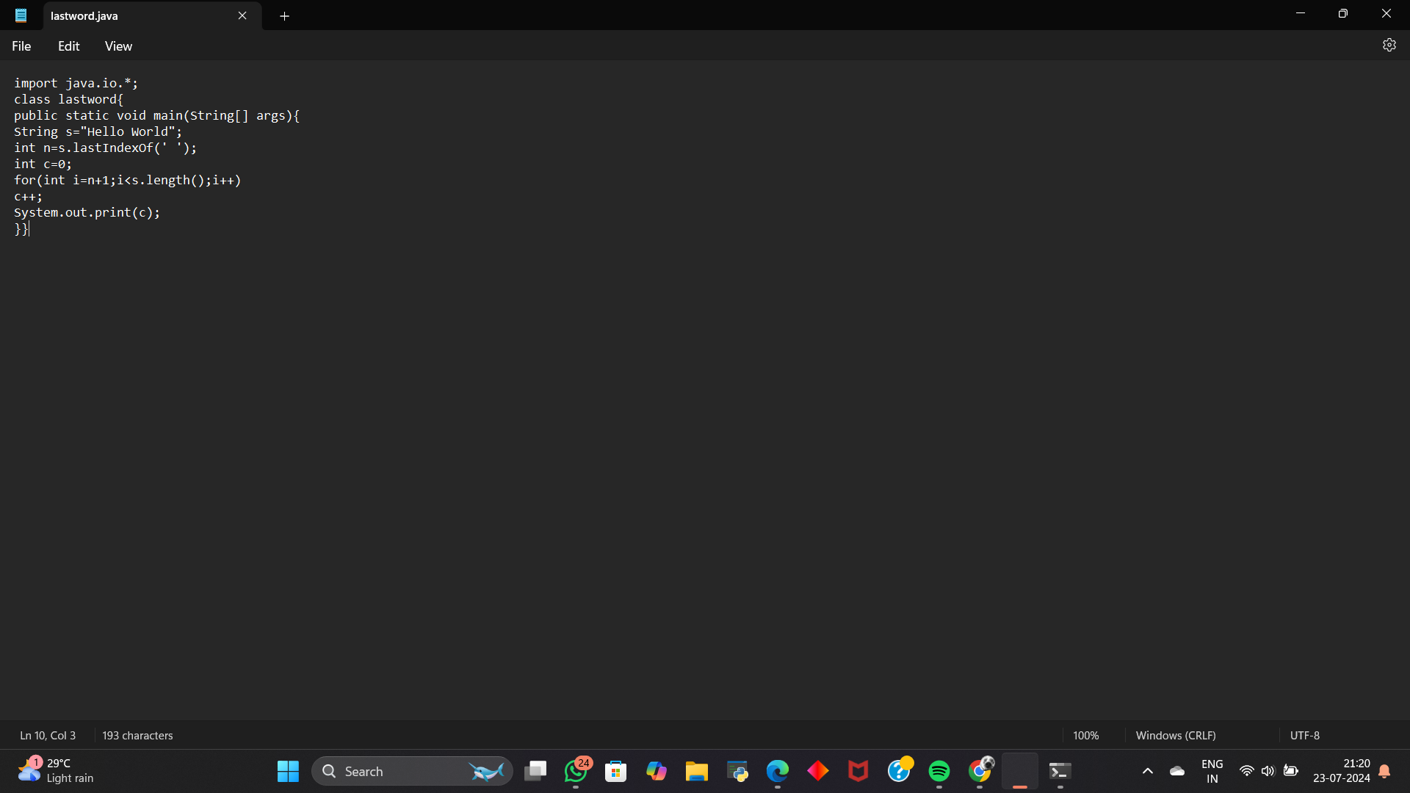

Output

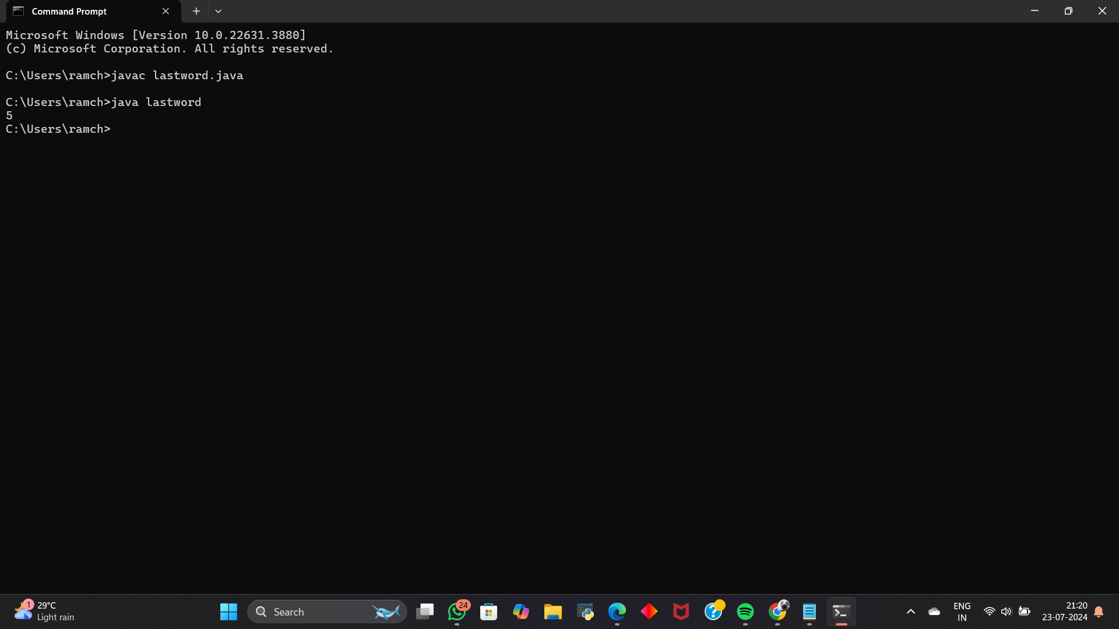

1. Write a Java program to find the maximum sum of a contiguous subarray within a one-dimensional array of integers

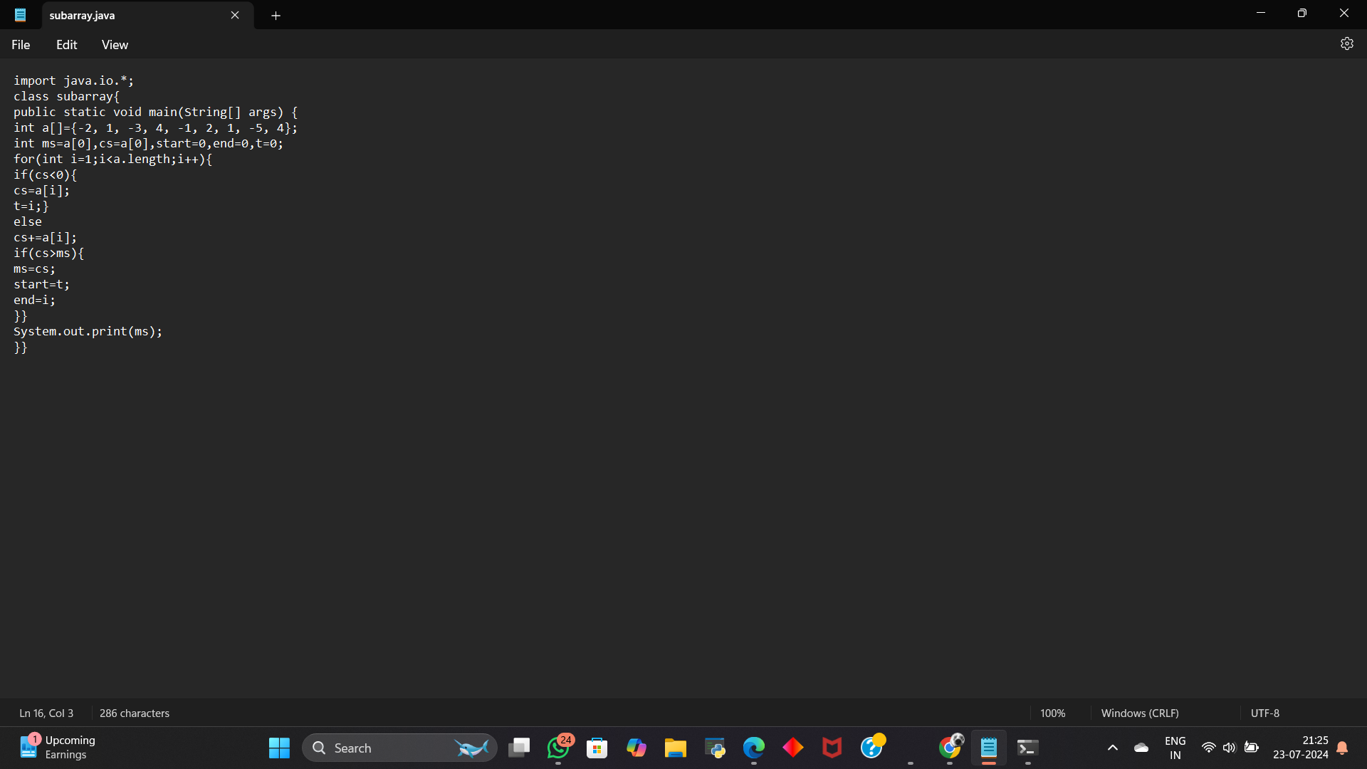

Output

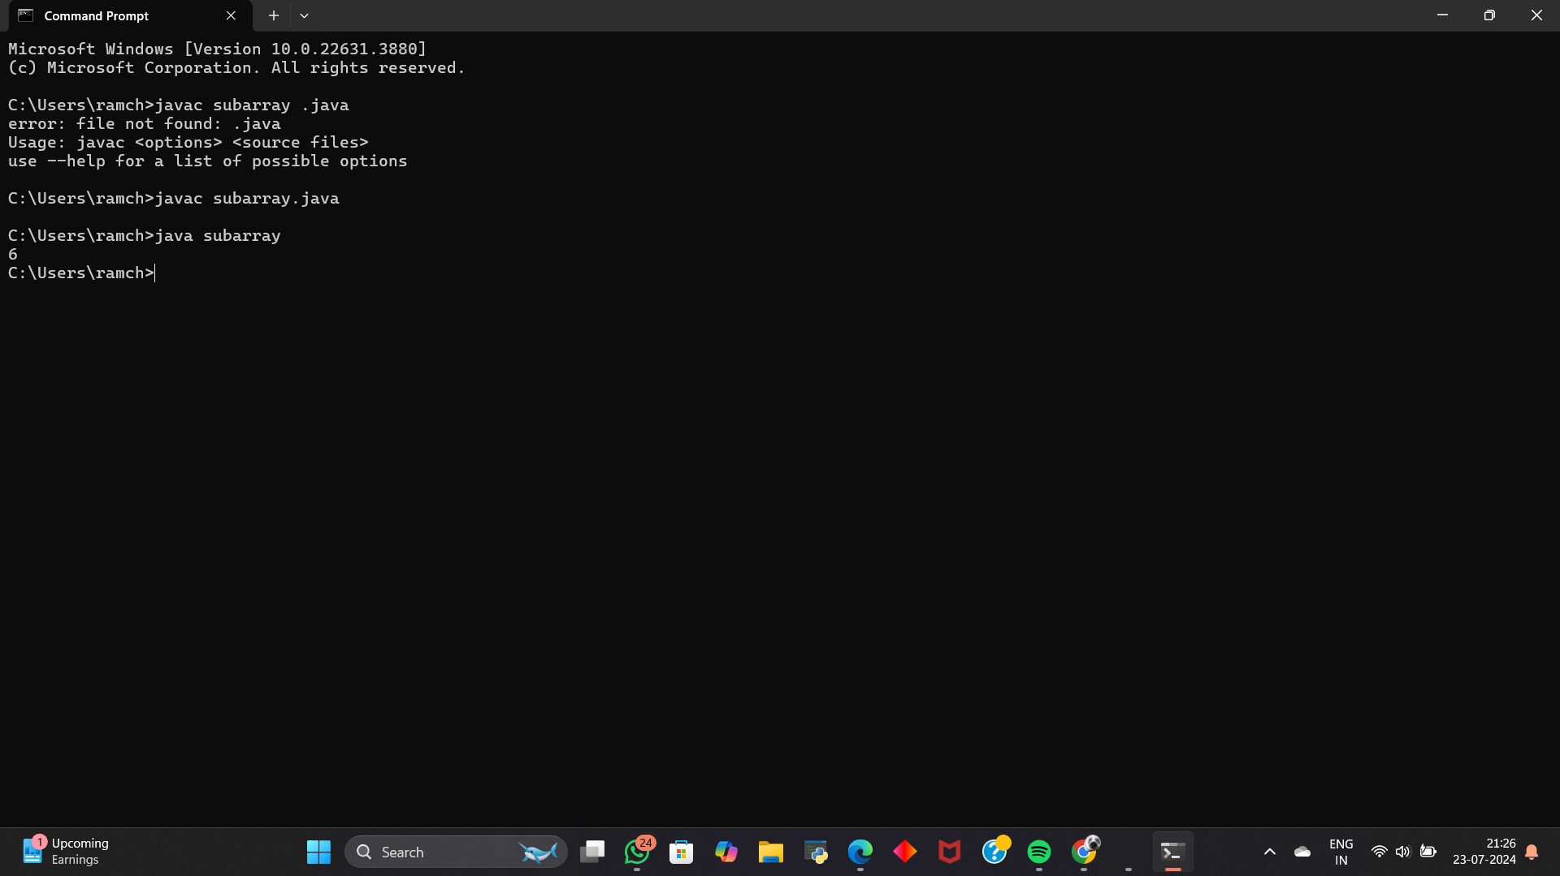

1. Write a Java program to find and print a peak element from an array. A peak element is defined as an element that is greater than its neighbors

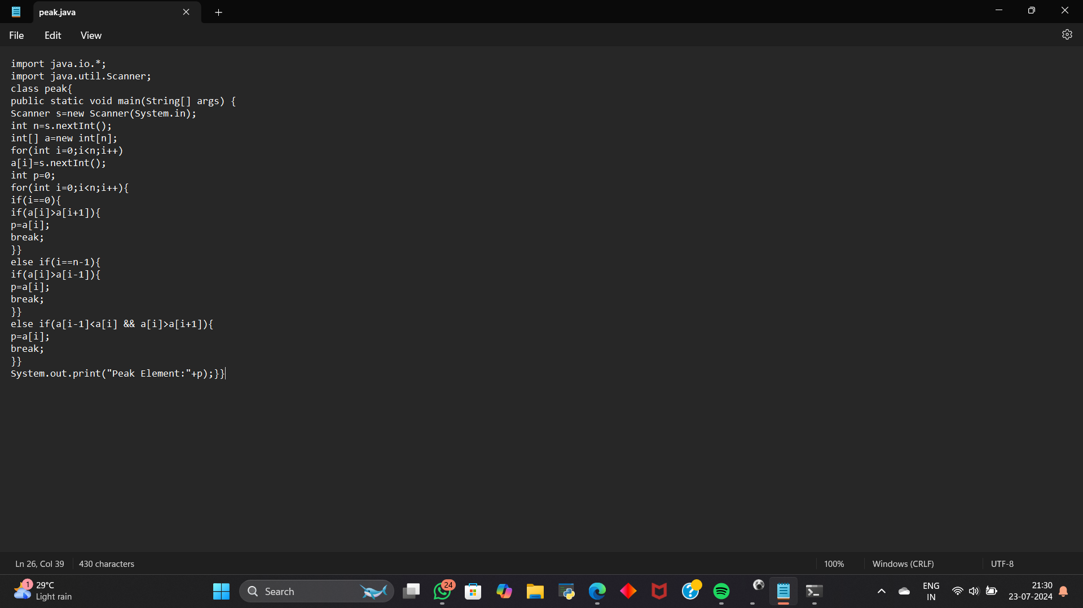

output

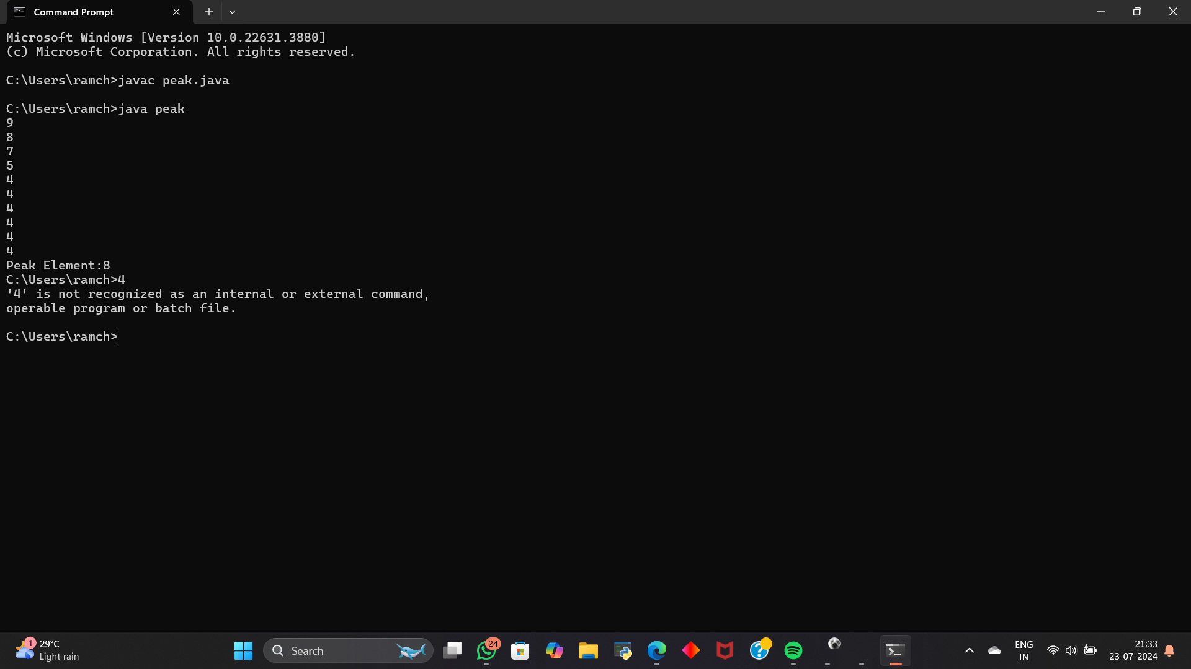

1. Write a Java program to sort an array in a zigzag fashion. A zigzag sorted array alternates between local minima and local maxima.

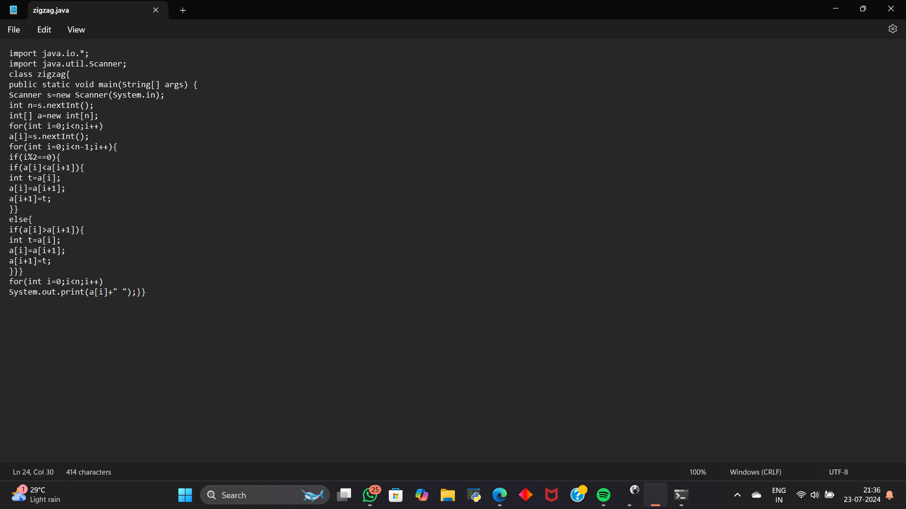

Output

